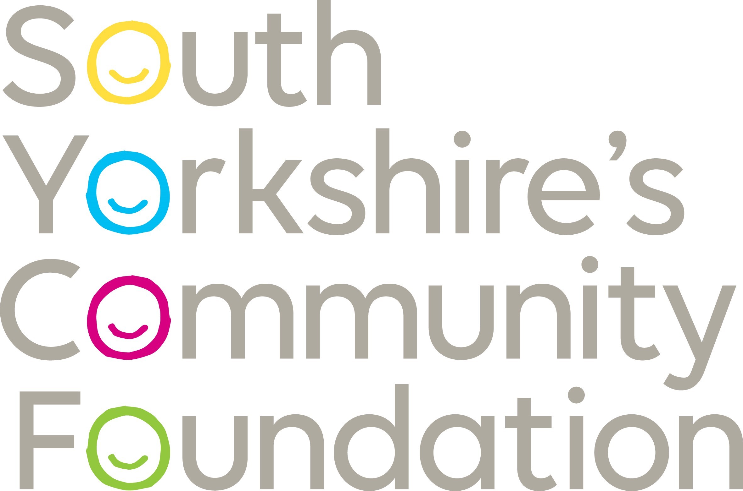

EQUAL OPPORTUNITIES MONITORING FORM
At South Yorkshire’s Community Foundation, we aim to eliminate direct or indirect discrimination, as covered by the Equality Act 2010, on grounds of: age, disability, gender reassignment, marriage, civil partnership, pregnancy, maternity, race, religion, belief, sex or sexual orientation. This Equal Opportunities Monitoring Form, which reflects our Equal Opportunities and Diversity Policy, is used to monitor progress with our equal opportunities and diversity objectives.
Please could you take a few moments to complete this form; the information is used solely for monitoring purposes and is separated from the rest of the application form before the interview.
Applicant Reference No: (Office use only)
Where did you see the position advertised?

PLEASE PLACE A “X” IN THE APPROPRIATE SECTION
GENDER
Would you describe yourself as: | ☐ Male | ☐ Female | ☐ Prefer not to say
Does your gender differ from that you were originally assigned at birth? | ☐ No | ☐ Yes | ☐ Prefer not to say

AGE
What is your age group? | ☐ Under 25  ☐ 25-34  ☐ 35-44 | ☐ 45-54  ☐ 55-64  ☐ 65 or over  ☐ Prefer not to say

DISABILITY
*According to the Equality Act 2010, a person has a disability if they have a physical or mental impairment and the impairment has a substantial and long-term adverse effect on their ability to perform normal day-to-day activities.
If invited to interview do you have any special requirements, e.g. Wheelchair access? | ☐ Yes | ☐ No
If yes, please specify.

Do you consider that you have a disability or a long-term health condition? | ☐Yes | ☐ No | ☐ Prefer not to say
What is the effect or impact of your disability or health condition on your ability to give your best at work?

SEXUAL ORIENTATION
What is your sexual orientation? (Please tick the box that best describes you)
☐ Bisexual  ☐ Gay Man  ☐ Gay Woman/Lesbian | ☐ Heterosexual/Straight  ☐ Other (please state)  ☐ Prefer not to say

RELATIONSHIP STATUS
How would you describe your relationship status? | ☐ Co-habiting | ☐ Civil Partnership | ☐ Married
How would you describe your relationship status? | ☐ Single | ☐ Prefer not to say

ETHNICITY
(The following sets of categories are for monitoring main characteristics from an equality and diversity perspective that will help us ensure that our policies and practices do not inadvertently discriminate against you. We will ensure that any information you provide here will only be used to monitor the effectiveness of our policies and will ensure the information remains confidential to the HR Team.)
How would you describe yourself? Choose ONE section from A to E, and then
tick the appropriate box
A - Asian or Asian British | B – Black/African/Caribbean/Black British
☐ Bangladeshi  ☐ Indian  ☐ Pakistani  ☐ Chinese  ☐ Prefer not to say  ☐ Any other Asian background (please state) | ☐ African  ☐ Caribbean  ☐ Prefer not to say  ☐ Any other Black/African/Caribbean background (please state)
C - White | D – Mixed/multiple ethnic groups
☐ British  ☐ English  ☐ Irish  ☐ Northern Irish  ☐ Scottish  ☐ Welsh  ☐ Gypsy or Irish Traveller  ☐ Prefer not to say  ☐ Any other white background (please state) | ☐ White and Asian  ☐ White and Black African  ☐ White and Black Caribbean  ☐ Prefer not to say  ☐ Any other mixed background (please state)

E – Other ethnic group
☐ Arab | ☐ Prefer not to say | ☐ Any other ethnic group (please state)

RELIGION OR BELIEF
Please tick the box that best describes you:
☐ Buddhist  ☐ Christian  ☐ Hindu  ☐ Jewish  ☐ Muslim | ☐ Sikh  ☐ Other Religion or Belief (please state) ……………………………………………………..  ☐ No Religion or Belief  ☐ Prefer not to say

Privacy Notice
SYCF is required to collect, store and process the information contained about you in this form in order to assess your application and adhere to our Equal Opportunities and Diversity Policy. Our Privacy Policy lists your information privacy rights (available on our website), which include the right to access the information we keep about you. Information will not be shared with any third parties without your consent. For candidates who do not gain employment with us, your information will be kept for the duration of your relationship with us and will then be deleted after one year. For candidates who do gain employment with us, your information will be kept for the duration of your contract and will then be deleted after six years.

