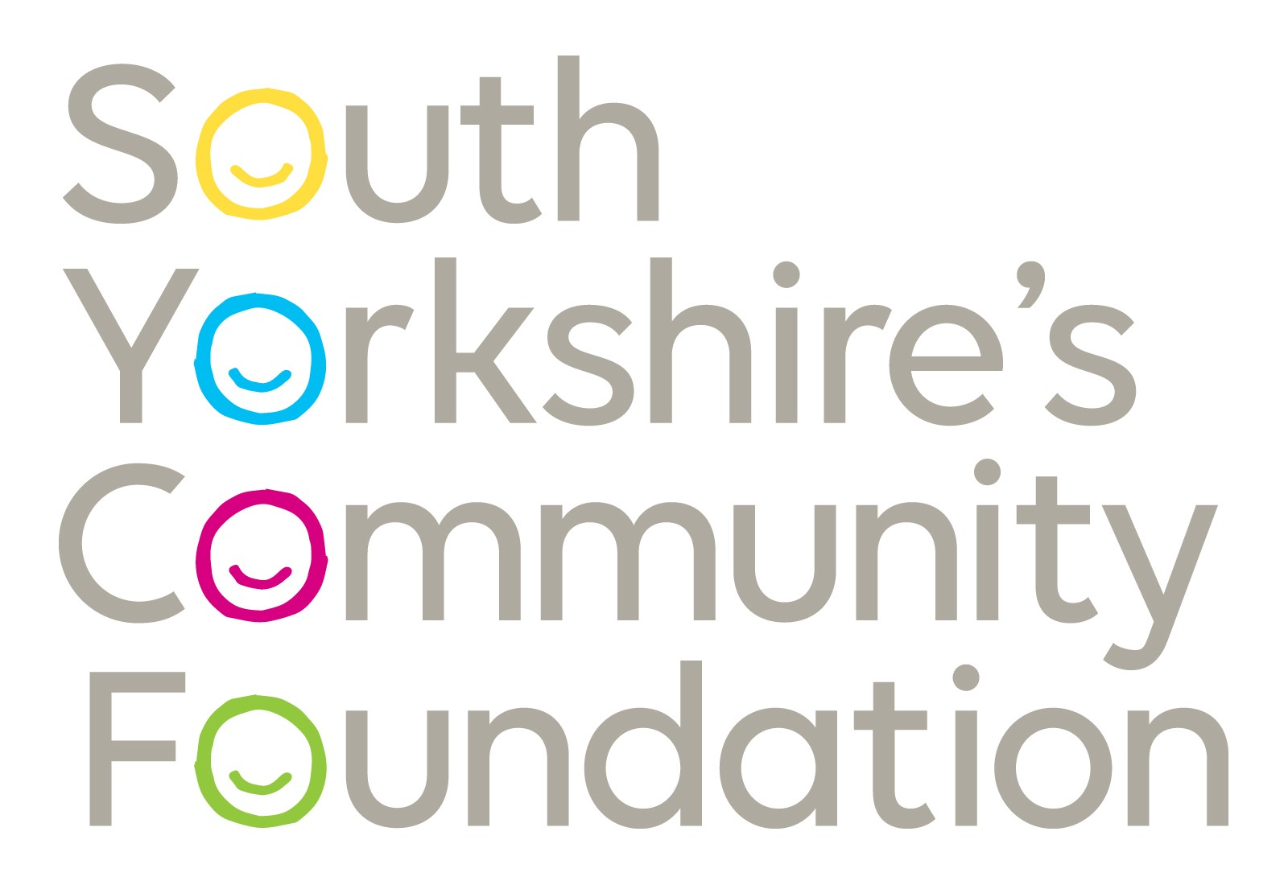

Small Grants Programme Overview

Who are Small Grants for?

These grants are intended for small, developing and less well-resourced groups and organisations from across South Yorkshire, where small amounts of funding can make a real difference.

Organisations / groups do not have to be a registered charity and the majority of grants are one-off payments of between £250 and £1,000.

We welcome applications from all community and voluntary groups and organisations operating for the benefit of South Yorkshire communities. Groups must therefore have beneficiaries who live in South Yorkshire and be locally led and run. This includes locally constituted and managed branches of national or large charities. The last financial annual income of the group should not be more than £10,000.

Which groups or activities will be prioritised for funding?

Higher priority will be given to those applications that can demonstrate how they will address some of the following needs to pay for one of event or equipment. If your group or activity will not meet these priorities, then you can still apply but it is less likely that you will receive funding from us:

- Groups that respond to their communities’ needs.
- Activities or projects that will support people whose needs can be clearly demonstrated.
- Groups whose main activities focus upon the advancement of education, promotion of good health or the relief of poverty and sickness.
- Groups that work in collaboration with other local community groups.
- Activities or projects that will engage people who face discrimination or disadvantage.
- Activities or projects that will produce a wide range of benefits and provide good value for money.

Who and what cannot be funded?

- Organisations that are national charities (unless locally led and run).
- Organisations that have substantial unrestricted funds and their last financial income was more than £10,000.
- Activities that promote political or religious beliefs. Groups that are based in a religious building can apply, providing the activity / project is open to all people in the community. Please contact the grants team to discuss eligibility if you are unsure.
- Statutory bodies e.g., schools/colleges, local councils. However, ‘Friends of’ or Parents’ Associations may be eligible to apply.
- Organisations or activities that support animals.
- Contributions to a large project where the amount applied for is less than one fifth (20%) of the total project cost.
- Retrospective funding – this includes activities that have already taken place or repayment of money that you have already spent.
- More than one application in a 12-month period.
- Consultancy fees or feasibility studies
- Sponsorship and/or fundraising events.
- Contributions to an Endowment.
- Minibuses or other vehicle purchases.
- Activities or organisations that are for personal profit.
- Grants for IT and associated equipment will be limited to no more than £400.

Please turn the page over for details of how to apply, or, if you wish to discuss your activity / project with us please telephone us on 0114 242 4294.

How do we apply?

To apply for a Small Grant, there are 2 forms to be completed, you need to:

- Complete the (SYCF) Small Grant Application Online Form online via the Foundation website www.sycf.org.uk or you can also request this form from us by e-mail at grants@sycf.org.uk or by telephone on 0114 242 4294. If you require help with the form, please contact us on the same number.
- The Reference form which is attached to the registration online form should be completed by your referee and return to us by email.

Group applying for the programme is required to provide.

- A copy of the group’s signed Constitution or Rules which should include a dissolution clause.
- Financial records
  - If your group is more than 12 months old, this should be a signed copy of your group’s most recent audited accounts.
  - If your group is less than 12 months old, this should be copies of your group’s income and expenditure records or a recent bank statement.
- Evidence of your group’s name such as a recent bank statement.
- Quotes (at least two) for equipment or services that you will have to purchase to run your activity / project (printed quotes, not links to websites).

What happens when we apply?

When we receive your application:

- The Foundation staff will check it to ensure that it meets our main eligibility criteria. If we have any queries, we will contact you either by email, telephone or in writing.
- Support and advice is available for groups, but groups must be aware that any support provided will not necessarily influence a successful outcome.
- All applications are assessed, and decisions are made internally.
- The Foundation may request a visit to your group.
- The Foundation may award a grant dependent on certain conditions (conditional offer) – in this case your payment will be sent once you have met / agreed to these conditions.

If your application is successful:

- Your group will be sent award letter which will have End of grants report form. The monitoring form must be returned to the Foundation as soon as funds have been spent. If this form is not completed, your group will not be eligible for further grant aid from the Foundation.
- Your group may be contacted once funding has been given, to arrange a visit to evaluate and audit your spending of the grant.
- Your group are expected to send Thank you letter to the Donor (s) of the Fund.
- Your group will be expected to include the Foundation in any publicity that your group arranges.

We look forward to hearing from you.

South Yorkshire Community Foundation The principal office of South Yorkshire’s Community Foundation and South Yorkshire Funding Advice Bureau is The Campus, Pack Horse Ln, High Green, Sheffield S35 3HY.
www.sycf.org.uk

