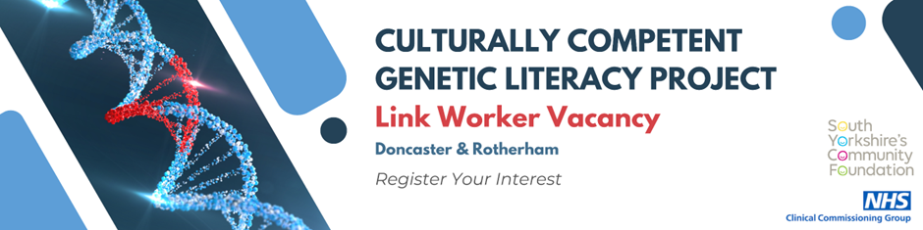
Interest Registration Form
NHS Clinical Commissioning Group (CCG) - Culturally Competent Genetic Literacy Project
Link worker Job description
Link workers connect people to community-based support, including activities and services that meet practical, social, and emotional needs that affect their health and wellbeing.
As part of the Culturally Competent Genetic Literacy Project, you will support communities in Doncaster and Rotherham by increasing the awareness and promoting services concerning the subject of close relative marriages and recessive genetic conditions. In doing so, you will be playing a key role in promoting the positive health and wellbeing of community members through increasing understanding into the genetic factors and genetic disorders.
Roles and Responsibilities
- To promote the Culturally Competent Genetic Literacy Project amongst families in the local areas in various groups and settings
- To identify formal and informal avenues to promote the project
- Build effective links and working partnerships with local organisations and community groups.
- To help build links between communities and the Close relative Midwife
- Work with existing community groups and organisations to sign post and refer families to the CR Midwife
- To help The CR Midwife identify appropriate settings for clinics
- To support the CR Midwife in setting up clinics in community settings
- Have conversations with families and encourage them to attend the clinics
- Promote the clinics to GP’s and health professionals
- Have sensitive conversations with families on the subject of close relative marriages and recessive genetic conditions
- Attend appropriate online meetings
- Contribute towards monitoring
- Attend training

Locations:
Doncaster – 1 worker
Rotherham – 1 worker
Pay: funding available up to £10,000 for 12 months
Hours: 14-16 per week
Applications welcome from organisations using existing employees or creating a new role.
Please fill out this form to register your interest in this vacancy - After submitting, you will be contacted by a member of the Culturally Competent Genetic Literacy Project.

DEADLINE: Monday 11th December at 9am.
Please fill out the following details:

First Name: |  | Last Name:
Email Address:
Phone Number:
Preferred method of contact: | Email ☐ |  | Phone ☐

To complete registering your interest, please return this document to:
Saima Ahmed - saimageneticsaware@gmail.com

For any further information please contact Saima in the first instance or alternatively
Jessica Dunphy - jessica.dunphy@nhs.net

Thank you for registering your interest in the vacancy.
A member of the Culturally Competent Genetic Literacy Project will be in contact with you shortly.

For further information please contact:
Saima Ahmed - saimageneticsaware@gmail.com
Jessica Dunphy - jessica.dunphy@nhs.net

